- Look at your body of work over the semester and choose 2 pieces that show your growth as an artist. Discuss each piece and how you grew in the following areas: application of materials, techniques and skills, artistic vision, use of the principles and elements, creativity, intuition and subject matter.
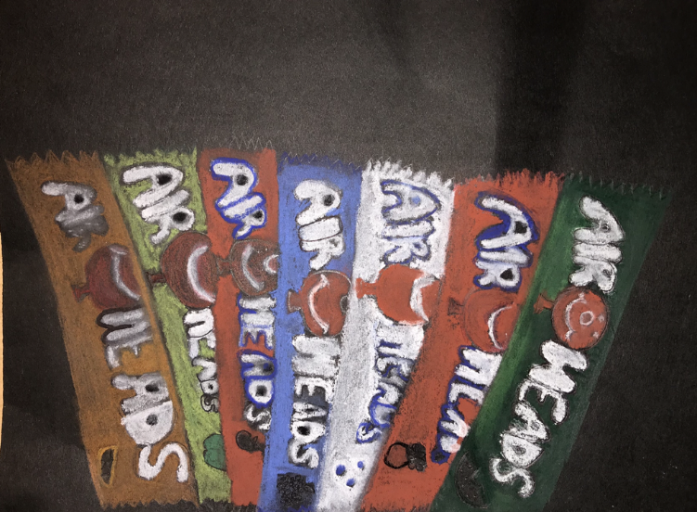
The first piece of art I chose is my candy drawing using pastels. This piece in my opinion was easy. This piece shows how I grew in terms of techniques and skills because it was the first time in a while that I’ve used pastels. I learned that pastels aren’t the easiest to work with. I would have to say using pastels benefited me because I feel as though pastels make the drawing look a lot better. In this drawing I feel as though I used the elements: color and value. The principles that represents this drawing are emphasis, rhythm, and variety. Something else I learned from this piece was that combining different pastel colors together is very difficult and takes time. This piece took me up to 2 days starting from the sketch to the final piece.
The second piece of art I chose is my clay food project. In my opinion, this clay project was easy and kind of difficult at the same time. This piece shows how I grew in terms of techniques and skills because I have never used to clay to make food. My first experience using clay was in 9th grade which was very nice. But this piece showed me that using clay isn’t that easy and takes time to make everything perfect. In this piece, I believe I used more principles then elements which were variety, emphasis, and movement. I learned that using clay is very messy and you have to be prepared to get your hands dirty. I also learned that when you use clay, you may want to bring some type of lotion for after because your skin well become dry.
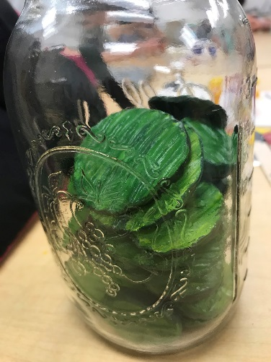
2. Choose 2 mini lessons that you felt were the most beneficial in your learning for that particular project. Include photos of these and explain thoroughly. Do you feel you needed more instruction for success? Explain or did you feel that the instruction given was enough to ensure success? Explain.
The first mini lesson I felt was the most beneficial was the 100 patterns. I believe this project was beneficial to me because it gave me an opportunity to be able to make multiple patterns all come together. This lesson was also some good practice for me to really see what type of patterns I could make. This mini lesson helped me discover many different patterns. I think for this mini lesson we had plenty of instruction and practice for success. I think the instruction given was enough to ensure success because the lesson was pretty straight forward. Overall, this lesson was not as difficult as I thought it would be. The only difficult thing about this lesson was having to think of 100 patterns to make look good.
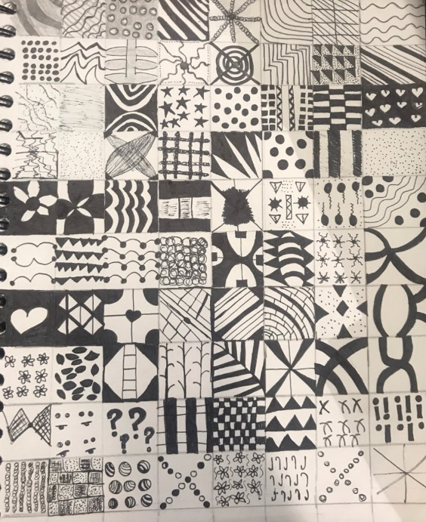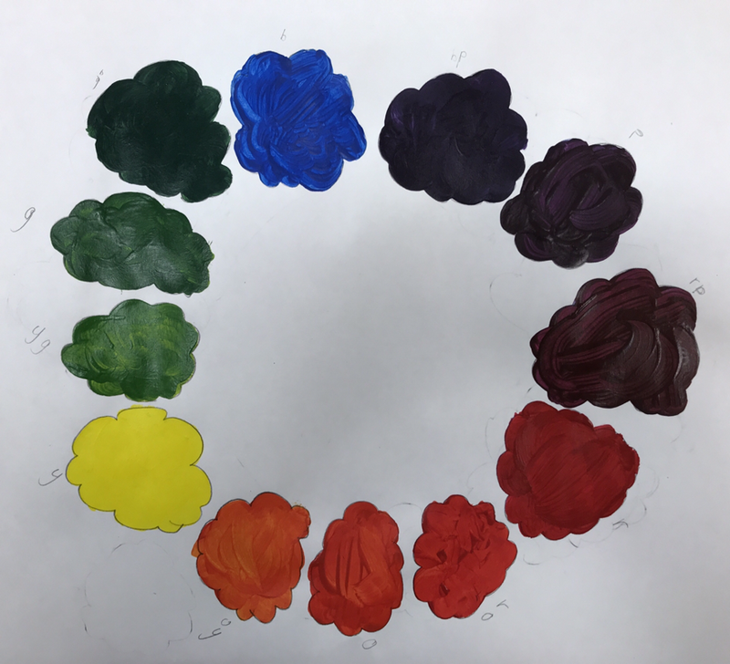
Another mini lesson I think was the most beneficial was the creative color wheel drawing. I think this was beneficial because it allowed me to be able to learn which colors I would have to mix to get a secondary color. I also think this mini lesson was beneficial because I thought at the end it was going to look really bad but it ended up looking really good. I feel as though I didn’t need any more instruction for success. I think I could have thought of something else other than doing “clouds” but I didn’t really have as many ideas in mind. This mini lesson helped me discover many colors I can make out of primary colors. Overall, I think this mini lesson wasn’t at all difficult because once I got the hang of it and become much easier than I thought it was going to be. Also this mini lesson took 2 days: one for planning and sketching and the other one for combining the colors together.

3. What medium was your favorite to work with? Explain why and how you were able to master the techniques associated with this medium. ​
I would have to say my favorite medium to work with this semester was the pastels. I say that because to me it was the easiest thing to work with. I was able to master techniques with this medium because we practiced with it more than once which to me was a lot of practice. We created different shapes including a sphere which to me was the easiest one. We also created a mini fruit project. Which is what the strawberry is on the left. I enjoyed this mini project because I got to see a lot more with the pastels. Overall, after doing this project, I learned that you have to know a little bit about pastels before using them because if you mess up you can’t erase. I also learned that pastels aren’t the cleanest medium in art but that they’re the funniest, in my opinion.
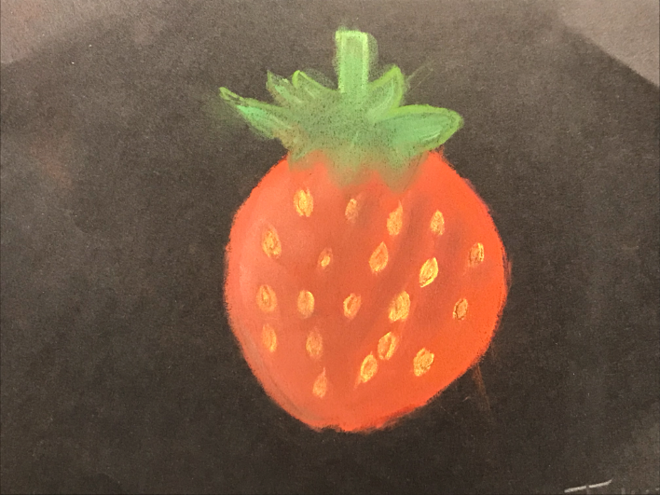

4. Discuss one project where you felt you were the least successful. Explain why you felt this way. What would you do differently to change this piece? Explain.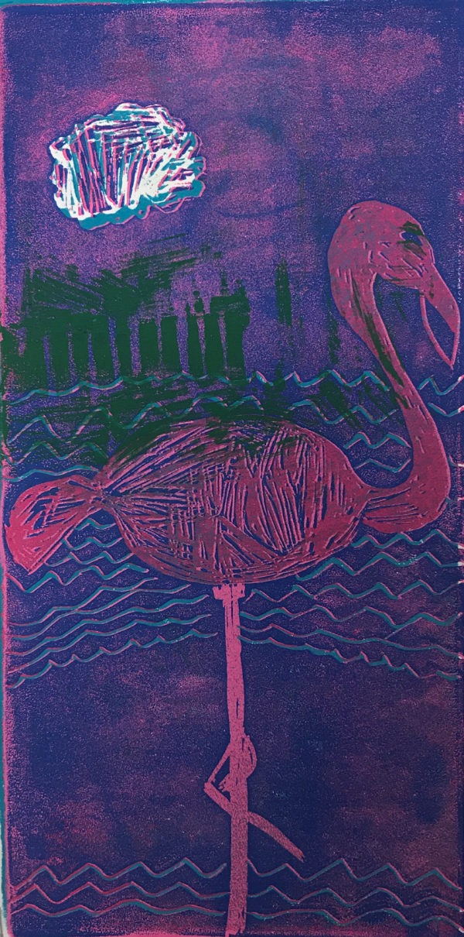
The one project where I feel I was the least successful was the printmaking project. I say that because the unity wasn’t as detailed as I thought it would be. Also whenever I layered another print on other, they never lined up, which made it look completely bad. Another thing it that I feel as though it wasn’t a 3-d design because it had no depth and it didn’t look as decent or even as good as I thought it would be. Something I would do differently to change this piece is to take my time. I would also try to align everything together so it won’t look as bad. I would also try to make it more detailed because in my opinion it just looks basic. I would try to remove a lot of the negative space out of the paper which would make it not look as bad.

